Software Requirements Specification:
Incident Correlation Engine (“ICE”)

Version: 1.9
Author: writer_agent
Date: 2026-03-26

  - Table of Contents
1 Introduction 4
1.1 Purpose 4
1.2 Scope 4
1.3 1.3 Definitions and Acronyms 4
1.4 1.4 References 5
2 Overall Description 5
2.1 System Context 5
2.2 High-Level Architecture 5
2.3 Design Constraints 6
2.4 Risks, Assumptions, Constraints, and Dependencies (RACD) 6
3 Specific Requirements 7
3.1 Functional Requirements 7
3.2 Non-Functional Requirements (NFR) 11
4 Interface Requirements 12

  - Revision History
Version | Date | Author | Description
1.0 | 2026-03-19 | Team | Initial draft
1.1-1.6 | 2026-03-23 | writer_agent | Incremental updates based on QA findings (F-001 to F-013).

Introduction

Purpose
This SRS defines the requirements for “ICE”, a backend service that correlates multi-sensor security events into incidents using density-based clustering.

Scope
“ICE” consumes events from RabbitMQ, and Syslog forwarder, applies deterministic suppression and detection rules, clusters related events via DBSCAN, and manages incident and event lifecycles in PostgreSQL.
It excludes frontend visualization and sensor-side development.

1.3 Definitions and Acronyms
Term | Definition
API | Application Programming Interface
C2 | Command & Control
Critical Response Criteria | A set of conditions (e.g., severity = 'Critical', specific MITRE techniques, or high-risk assets) that trigger immediate automated response and bypass standard suppression logic.
DBSCAN | Density-Based Spatial Clustering of Applications with Noise
DDL | Data Definition Language
DDoS | Distributed Denial of Service
DFD | Data Flow Diagram
DLQ | Dead Letter Queue — a queue for messages that cannot be processed
EDA | Event-Driven Architecture
EDR | Endpoint Detection and Response sensor
ELK | Elasticsearch, Logstash, Kibana stack
Idempotent | An operation that can be applied multiple times without changing the result beyond the initial application
JSON | JavaScript Object Notation
MITRE ATT&CK | Adversarial Tactics, Techniques & Common Knowledge framework
OAuth2/OIDC | OpenID Connect / OAuth 2.0
OSF | OS Forensics — Host-based forensic sensor (referred to as "OS" in some diagrams)
p95 | 95th percentile — a measure of latency where 95% of requests are faster
PK | Primary Key
RBAC | Role-Based Access Control
REST | Representational State Transfer
RF | Radio Frequency sensor
RPO | Recovery Point Objective
RTO | Recovery Time Objective
SQL | Structured Query Language
TLS | Transport Layer Security
TTP | Tactics, Techniques, and Procedures
UUID | Universally Unique Identifier

1.4 References
- IEEE 29148:2018 (Requirements Engineering)
- MITRE ATT&CK v14
- Technical Specification: Correlation Engine Architecture
- `corr_input.json` (Sample observation model v1.0.0)

Overall Description

System Context
“ICE” is a core component of an Event-Driven Architecture (EDA). It sits between the sensor ingestion layer and the persistence layer.
The system's position as a central processing hub, receiving events from Network, Forensic, and RF sensors via RabbitMQ as well as syslog EDR events and providing incident data to security dashboard.
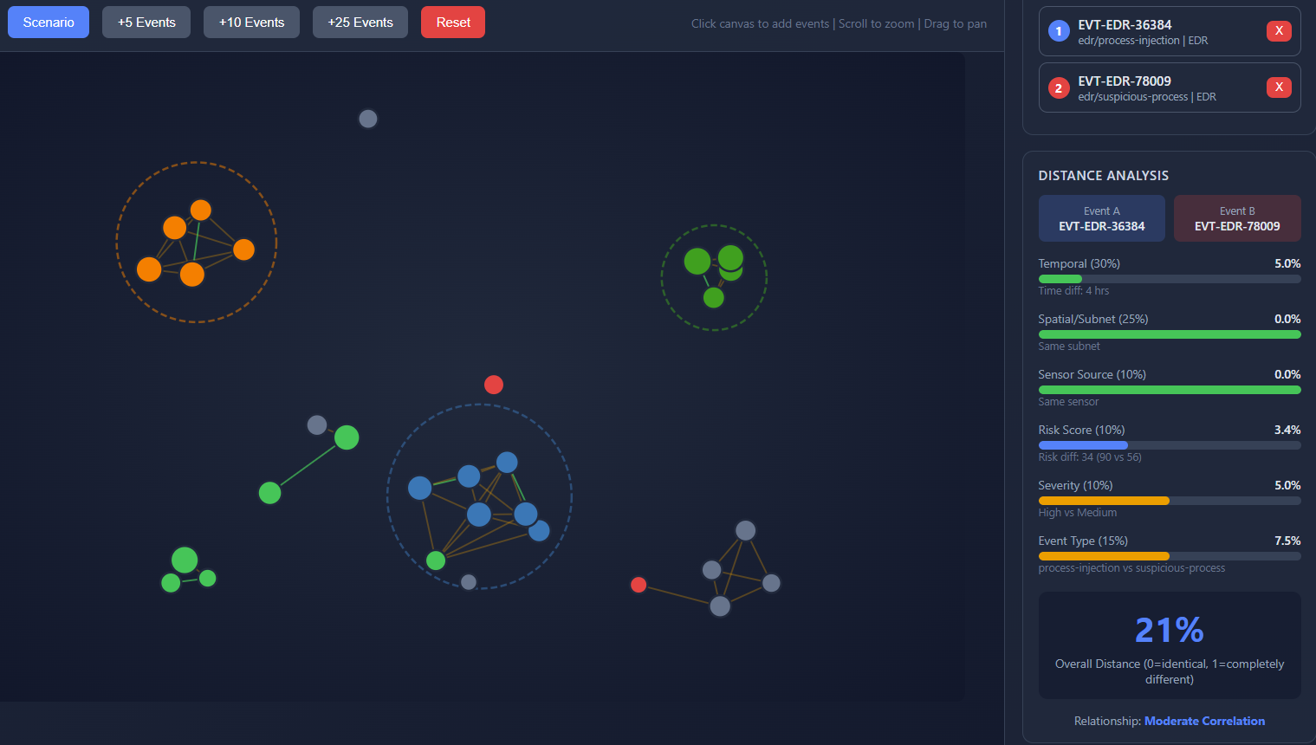
Figure 1 - Visualization DEMO mockup

High-Level Architecture
The system follows a four-stage pipeline for transforming raw telemetry into actionable security incidents.
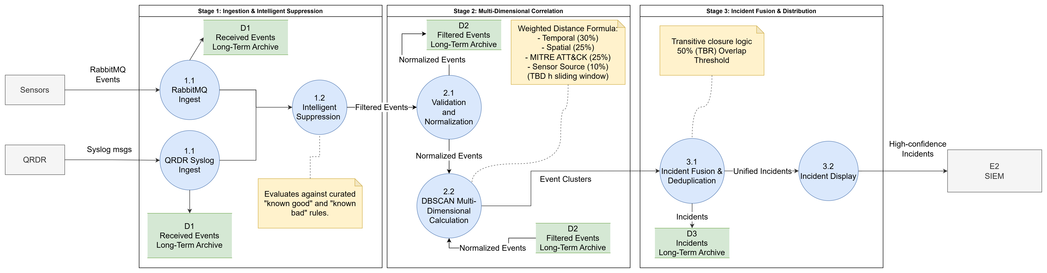
Figure 2 - Level 2 DFD
Figure 1 depicts the detailed internal logic of the event processing pipeline, showing the flow of data through normalization, enrichment, and the multi-stage filtering process.
- Ingestion & Normalization:
- Parse & Validate: Ensures incoming JSON matches the schema.
- Normalize: Maps sensor-specific fields to a common internal schema.
- Enrich: Adds contextual data (e.g., asset ownership, site location).
- Suppression & Aggregation:
- Duplicate Detection: Identifies and drops redundant events within a short time window.
- Time-Window Aggregation: Groups identical events from the same source to reduce noise.
- False Positive Filtering: Applies suppression rules to filter known benign activity.
- Correlation & Clustering:
- DBSCAN Clustering: Groups events based on multi-dimensional similarity.
- Multi-Dim Distance Calc: Calculates the "distance" between events using weighted attributes.
- MITRE ATT&CK Mapping: Associates clusters with specific attack stages.
- Incident Management (4.x):
- Create Incident: Generates a new incident record for valid clusters.
- Update State: Manages the lifecycle (e.g., auto-escalation).
- Notify: Publishes alerts to RabbitMQ for downstream consumption.

Design Constraints
- Throughput: < 10,000 events/hour.
- Latency: Event-to-incident < 20s (p95).
- Algorithm: HDBSCAN (primary).

Risks, Assumptions, Constraints, and Dependencies (RACD)

Assumptions
- Network Reliability: The internal network between RabbitMQ, “ICE”, and PostgreSQL is assumed to be stable and low-latency. (less than 20 sec end to end)
- RabbitMQ Availability: It is assumed that RabbitMQ is configured for high availability and message durability.
- PostgreSQL Performance: The database is assumed to be tuned for high-write throughput.

Dependencies
- RabbitMQ: Required for event ingestion.
- PostgreSQL: Required for rule storage and incident management.
- Elasticsearch: Required for long-term event archiving.

Constraints
- Data Format: All incoming events must comply with the schema.
- Resource Limits: The system must operate within the allocated Kubernetes resource limits (CPU/Memory).

Risks
- Data Loss: Failure of RabbitMQ before message acknowledgement could lead to data loss.
- Clustering Performance: High event density (e.g., during a DDoS attack) may cause DBSCAN performance degradation.
- Schema Evolution: Changes to the sensor event schema without updating will lead to ingestion failures.
- Event loops: Events that propagated to the QRDR and were sent again as input may cause avalanche cascade effect if not filtered. Events originated within the system itself can also degrade the ICE system performance, thus events are limited to UUT only

Specific Requirements

Functional Requirements

Event Ingestion (EC)
- REQ-FUNC-001: The system SHALL consume events from queues.
- REQ-FUNC-002: The system SHALL validate events against the schema.
- REQ-FUNC-003: The system SHALL ensure idempotent processing via the `event_id` field (mapped from `eventId` in JSON).
- REQ-FUNC-004: The system SHALL persist events to PostgreSQL within 500ms of ingestion.
- REQ-FUNC-005: The system SHALL archive events to Elasticsearch within 2s of ingestion for real-time indexing and search.

Suppression Service (SS)
- REQ-FUNC-010: The system SHALL support suppression rules based on IP, event type, sensor, and hostname.
- REQ-FUNC-011: Suppressed events SHALL NOT be correlated.
- REQ-FUNC-012: The system SHALL support a Suppression Exclusion List to ensure events from critical assets bypass suppression.

Distance Calculation
- REQ-FUNC-030: The system SHALL implement HDBSCAN clustering using a multi-dimensional distance algorithm.
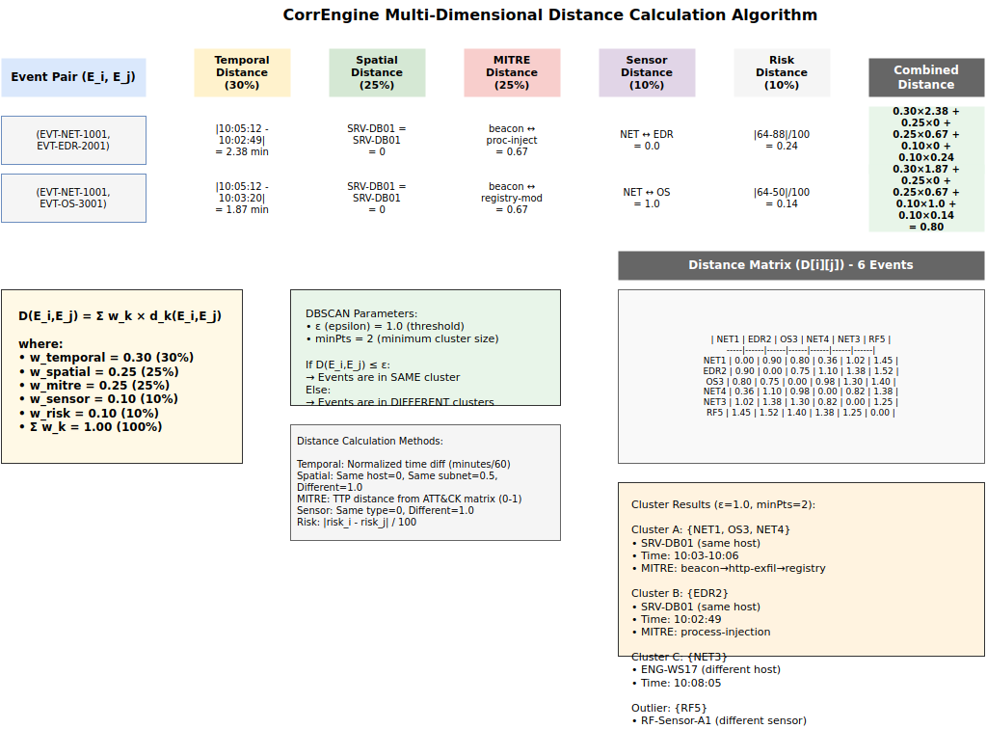
Figure 3 - Multi-Dimensional Distance Algorithm
Figure 2 visualizes the multi-dimensional distance calculation logic, illustrating how temporal, spatial, MITRE, sensor, and risk attributes are weighted and combined to determine event similarity.
REQ-FUNC-031: The system SHALL calculate distance D(Eᵢ, Eⱼ) = Σ(wₖ × dₖ) using the following weights and normalization methods:
Temporal (wₜ = 0.30): dₜ = |tᵢ − tⱼ| / 60 (normalized time difference in minutes, capped at 1.0).
Spatial (wₛ = 0.25): dₛ = 0.0 if hostnames match; 0.5 if in the same subnet; 1.0 otherwise.
MITRE (wₘ = 0.25): dₘ = Jaccard distance between sets of associated MITRE tactics (1 − |A ∩ B| / |A ∪ B|).
Sensor (wₛₙ = 0.10): dₛₙ = 0.0 if sensor types match; 1.0 otherwise.
Risk (wᵣ = 0.10): dᵣ = |Rᵢ − Rⱼ| / 100 (linear scaling of risk score difference).
REQ-FUNC-032: The system SHALL identify points as follows:
Core Point: An event with ≥ minPts neighbors within distance ϵ.
Border Point: An event within distance ϵ of a core point but with < minPts neighbors.
Noise: An event that is neither a core nor a border point.
REQ-FUNC-033: The system SHALL create incidents for clusters formed by core and border points.
REQ-FUNC-034: The system SHALL merge incidents sharing > 50% of events from either incident.

Incident States
- REQ-FUNC-035: The system SHALL manage incident states according to the state machine below.
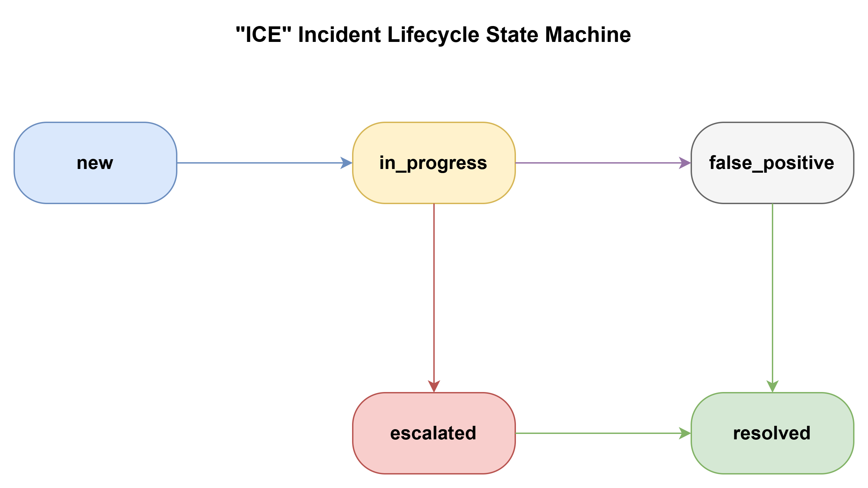
Figure 4 - Incident Lifecycle State Machine
Figure 3 defines the incident lifecycle and its associated state transitions, illustrating the path from initial detection to final resolution or closure.

- REQ-FUNC-036: The system SHALL support configurable DBSCAN parameters:

- ϵ (epsilon): The maximum distance between two samples for one to be considered as in the neighborhood of the other.

- minPts: The number of samples in a neighborhood for a point to be considered as a core point.

- REQ-FUNC-037: The system SHALL automatically transition incidents from `in_progress` to `escalated` if the aggregate risk score exceeds a configurable threshold or if a critical asset is involved.

Numerical Example: Multi-Dimensional Distance Calculation
Using 5 events derived from the distance algorithm model illustrated in Figure 3:
Event ID | Hostname | Event Type | Time | Sensor Type | MITRE Tactic
NET1 | SRV-DB01 | Type1 | 10:05:12 | Network | Command and Control
EDR2 | SRV-DB01 | Type2 | 10:02:49 | EDR | Execution
OS3 | SRV-DB01 | Type3 | 10:03:20 | OSF | Defense Evasion
NET4 | SRV-DB01 | Type4 | 10:06:20 | Network | Exfiltration
NET3 | ENG-WS17 | Type1 | 10:08:05 | Network | Command and Control

Distance Matrix (D[i][j]):
Calculated using the exact formula and weights defined in REQ-FUNC-031, with all components capped at 1.0.
 | NET1 | EDR2 | OS3 | NET4 | NET3 | RF5
NET1 | 0.000 | 0.674 | 0.664 | 0.552 | 0.576 | 0.904
EDR2 | 0.674 | 0.000 | 0.543 | 0.676 | 0.950 | 0.928
OS3 | 0.664 | 0.543 | 0.000 | 0.662 | 0.912 | 0.910
NET4 | 0.552 | 0.676 | 0.662 | 0.000 | 0.824 | 0.902
NET3 | 0.576 | 0.950 | 0.912 | 0.824 | 0.000 | 0.922
RF5 | 0.904 | 0.928 | 0.910 | 0.902 | 0.922 | 0.000

DBSCAN Results (ϵ = 0.7, minPts = 2):
- Cluster 1: {NET1, EDR2, OS3, NET4, NET3} — A complex multi-stage attack. NET1 acts as a core point connecting events on SRV-DB01 (EDR2, OS3, NET4) and the beaconing from ENG-WS17 (NET3).
- Outliers: {RF5} — Isolated RF event with no neighbors within the ϵ threshold.
Note: The diagram in Figure 3-1 provides a conceptual overview of the weighting components; the matrix above reflects the precise implementation logic required for production clustering.

Non-Functional Requirements (NFR)

Security
- REQ-NFR-001: All data in transit SHALL be encrypted using TLS 1.3.
- REQ-NFR-002: All data at rest in PostgreSQL and Elasticsearch SHALL be encrypted using AES-256.
- REQ-NFR-003: Access to the REST API SHALL be authenticated via OAuth2/OIDC.
- REQ-NFR-004: The system SHALL implement Role-Based Access Control (RBAC) for all management operations.

Reliability and Availability
- REQ-NFR-010: The system SHALL maintain 99.9% availability (excluding scheduled maintenance).
- REQ-NFR-011: The system SHALL have a Recovery Time Objective (RTO) of less than 1 hour.
- REQ-NFR-012: The system SHALL have a Recovery Point Objective (RPO) of less than 5 minutes.
- REQ-NFR-013: The system SHALL handle RabbitMQ connection drops with automatic retry and exponential backoff.

Performance and Scalability
- REQ-NFR-020: The system SHALL support horizontal scaling of the EventConsumer and IncidentManager services.
- REQ-NFR-021: The system SHALL process events with a p95 latency of < 5 seconds from ingestion to incident creation.
- REQ-NFR-022: The system SHALL support a sustained throughput of 10,000 events per second.

Maintainability
- REQ-NFR-030: The system SHALL export metrics in Prometheus format.
- REQ-NFR-031: The system SHALL log all errors and critical events to a centralized logging system (e.g., ELK stack).

Interface Requirements
- REQ-INT-001: The system SHALL use RabbitMQ with durable queues, JSON schema v1.0.0, and manual acknowledgement (ACK).
- REQ-INT-002: The system SHALL use a PostgreSQL connection pool of size 20 with a 30s statement timeout.
- REQ-INT-003: The system SHALL maintain a 90-day retention period and 5 shards in Elasticsearch. Operational data in PostgreSQL (events and incidents) SHALL be retained for 30 days to support active lifecycle management; after 30 days, records SHALL be purged from PostgreSQL.
- REQ-INT-004: The system SHALL provide a REST API with endpoints for `/api/v1/incidents`, `/api/v1/rules`, and `/api/v1/commands`.

